# **Software Requirements Specification**

# **Version <Version 1>**

# **<ABC FAST SOCIETY>**

# **Team <Group 9>**

|  |  |  |
| --- | --- | --- |
| Member Name | Member Roll # | Primary Responsibility |
| Muhammad Zubair | L15-4034 | Use Case and analysis |
| Taimoor Mirza | L14-4520 | Non Functional and other requirement writing |
| Muhammad Fahad | L15-4379 | Basic introduction of this Project writing |
| M. Jamal Butt | L15-4255 | Use Case and analysis |
| Abdul Rafey Tahir | L14-4014 | Basic introduction of this Project writing |

Table of Contents

Revision History 3

1. Introduction 4

1.1 Product 4

1.2 Scope 4

1.3 Business Goal 4

1.4 Document Conventions 5

1.5 References 5

2. Overall Description 6

2.1 Product Features 6

2.2 User Classes and Characteristics 6

2.3 Operating Environment 6

2.4 Design and Implementation Constraints 7

2.5 Assumptions and Dependencies 7

3. Functional Requirements 8

3.1 Use-Case 1 8

3.2 Use-Case 2 9

3.3 Use-Case 3 11

3.4 Use-Case 4 12

3.5 Use-Case 5 14

3.6 Use-Case 6 15

3.7 Use-Case 7 16

3.8 Use-Case 8 17

3.9 Use-Case 9 19

3.11 Use-Case 11 22

3.12 Use-Case 12 23

3.13 Use-Case 13 24

3.14 Use-Case 14 26

3.15 Use-Case 15 27

3.17 Use-Case 17 29

3.18 Use-Case 18 30

3.19 Use-Case 19 31

3.20 Use-Case 20 32

4. Nonfunctional Requirements 34

4.1 Security 34

4.2 Performance 34

4.3 Usability 34

5. Other Requirements 35

Appendix A: Glossary 36

Appendix B: Analysis Models 37

Appendix C: Design Models 44

# Revision History

|  |  |  |  |
| --- | --- | --- | --- |
| Name(s) | Date | Reason(s) For Change(s) | Version |
|  |  |  |  |
|  |  |  |  |

# 1. Introduction

## 1.1 Product

This project is about creating a website for ABC Society of Fast Nuces . In the website, a society can publish news, events, team hierarchy and book bank. The purpose of this project is to develop a website that can help students of FAST to find information about any ABC Society. Its features will enable students to see information about news, events etc. of the society. Societies usually promote themselves by using social networking websites. It is very hard to maintain information in a proper format on these sites. Students have to scroll and search a lot to find relevant information about the society. This website is a solution to all these issues. A user will be able to find appropriate and necessary information in just a few seconds according to his/her interest.

## 1.2 Scope

Admin Students can Create, Edit and Delete Information about

* News of the society
* Events of the society.
* Team and faculty members of the society.
* Book bank of the society.

Non Admin Students can View Information About

* News of the society
* Events of the society
* Team and faculty of the society
* Books in the book bank of the society
* Contact Information of the society

## 1.3 Business Goal

The objective of this website is to facilitate students and society. With the help of this website, people can have proper interaction with the society. Society can beforehand post different announcements, while students can easily view them.

## 1.4 Document Conventions

No special conventions were followed. But we only want to mention that all diagrams were made using star uml software.

## 1.5 References

[1] Orgnanization, S. (2018). *StarUML*. [online] Staruml.io. Available at: http://staruml.io/ [Accessed 18 Nov. 2018].

# 

# 2. Overall Description

## 2.1 Product Features

ABC Fast Society allows administrator of society to add, update and delete information about different events, news and books that society have in its book bank. Administrator can also add society members as well as advisors. Administrator can also update and remove profile information of advisors and team members. Users with non administrative privileges can only view information about events, news, books and members of society .

## 2.2 User Classes and Characteristics

In terms of users, there will be 2 types: Admin and non admin.

Admin is a privileged role and can perform all sorts of functions including adding, updating, deleting information about events, news, team members, advisors and book bank of society. Admin should have a basic understanding of how to use a website, no special technical details of web programming required form admin. Admin would use a password secured account. Admin should have a understanding of English .Frequency of use of admin depend how much admin want to make changes to data of society as there would be only one admin so frequency of use would be at most 10 to 15 at most as society information update less frequently.

Non admin user can only view information about events, news, team members , advisors and book bank of society. Non admin should have a basic understanding of how to use a website, no special technical details of web programming required form admin. Non Admin can access website by only writing address of website. Non admin should have understanding of English .Frequency of use of non admin users depend on number of users .As this website would be limited to usually only to people taking part in event of society and people who want to know about this society so on average there would be 200-300 users a day.

## 2.3 Operating Environment

ABC Fast Society application utilizes following tools and frameworks on server:

* PHP v7.2 (backend development)
* MySql v5.7.24 (database development)
* Mobirise (GUI tools for creating front end layouts)
* XAMPP (application server)

User can operate application on laptop/tablet/smart phones having either of the following browsers:

* Firefox
* Chrome
* Opera

## 2.4 Design and Implementation Constraints

No design and Implementation constraint were faced. As all the technologies which are mentioned in section 2.3 are free to use so there are no legal constraints. Hardware limitations also do not exist since the application doesn’t demand extensive computations. Finally, this system doesn’t utilize any third party services (libraries/APIs) so it doesn’t depend on other companies.

## 2.5 Assumptions and Dependencies

From user’s perspective, operator should have basic level command over English language since all the content uploaded on the website and the navigation system follows it. If user does not understand English than user can not do any useful work on website. Operator should also possess adequate Wi-Fi device since it’s an online application.

From technical perspective, we have assumed that data synching with **mobirise** will remain consistent i.e. there will be no bottleneck from Mobirise side. If mobirise software would not provide good service the service of our website could get affected.

# 3. Functional Requirements

## 3.1 Use-Case 1

|  |  |  |  |
| --- | --- | --- | --- |
| Identifier | | UC-1 | |
| Purpose | | Adding society executive | |
| Priority | | Medium | |
| Actors | | Admin | |
| Pre-conditions | | CRUD team page is currently online. Admin knows about team member details. | |
| Post-conditions | | An executive team member will be added. | |
| Typical Course of Action | | | |
| S# | Actor Action | | System Response |
| 1 | Admin will click on the, ‘Add Button’. | |  |
| 2 |  | | A form will be available/visible to the admin. |
| 3 | Admin will enter information about the society member. | |  |
| 4 | Admin will click on the Submit button. | |  |
| 5 |  | | Notification saying, “Person added successfully” will be displayed. |
| 6 |  | | Redirects back to the CRUD team page. |
| Added person already exists. | | | |
| S# | Actor Action | | System Response |
| 5 |  | | Notification saying, “Person cannot be added. Entity already exists.” will be displayed. |
| 6 |  | | Redirects back to the CRUD team page. |
|  |  |  |  |

Table 1: UC-1

## 3.2 Use-Case 2

|  |  |  |  |
| --- | --- | --- | --- |
| Identifier | | UC-2 | |
| Purpose | | Editing society executive information. | |
| Priority | | High | |
| Actors | | Admin | |
| Pre-conditions | | CRUD team page is currently online. Admin knows about team member details. | |
| Post-conditions | | An executive team member information will be updated. | |
| Typical Course of Action | | | |
| S# | Actor Action | | System Response |
| 1 | Admin will click on the, ‘Edit Button’. | |  |
| 2 |  | | A form will be available/visible to the admin. |
| 3 |  | | Prior information of the team executive will be displayed inside the form. |
| 4 | Admin will edit information about the society member. | |  |
| 5 | Admin will click on the Submit button. | |  |
| 6 |  | | Notification saying, “Person edited successfully” will be displayed. |
| 7 |  | | Redirects back to the CRUD team page. |
|  |  |  |  |

Table 2: UC-2

## 3.3 Use-Case 3

|  |  |  |  |
| --- | --- | --- | --- |
| Identifier | | UC-3 | |
| Purpose | | Deleting society executive. | |
| Priority | | High | |
| Actors | | Admin | |
| Pre-conditions | | CRUD team page is currently online. Admin knows about team member details. | |
| Post-conditions | | An executive team member will be deleted. | |
| Typical Course of Action | | | |
| S# | Actor Action | | System Response |
| 1 | Admin will click on the, ‘Delete Button’. | |  |
| 2 |  | | Notification saying, “Person deleted successfully” will be displayed. |
| 3 | Admin will click ‘Ok’ on the prompt to continue with the deletion | |  |
| 4 |  | | Redirects back to the CRUD team page. |
|  |  |  |  |

Table 3: UC-3

## 3.4 Use-Case 4

|  |  |  |  |
| --- | --- | --- | --- |
| Identifier | | UC-4 | |
| Purpose | | Adding society faculty advisor | |
| Priority | | Medium | |
| Actors | | Admin | |
| Pre-conditions | | CRUD faculty page is currently online. Admin knows about faculty advisor details. | |
| Post-conditions | | A faculty member will be added. | |
| Typical Course of Action | | | |
| S# | Actor Action | | System Response |
| 1 | Admin will click on the, ‘Add Button’. | |  |
| 2 |  | | A form will be available/visible to the admin. |
| 3 | Admin will enter information about the faculty advisor. | |  |
| 4 | Admin will click on the Submit button. | |  |
| 5 |  | | Notification saying, “Person added successfully” will be displayed. |
| 6 |  | | Redirects back to the CRUD faculty page. |
| Added person already exists. | | | |
| S# | Actor Action | | System Response |
| 5 |  | | Notification saying, “Person cannot be added. Entity already exists.” will be displayed. |
| 6 |  | | Redirects back to the CRUD faculty page. |
|  |  |  |  |

Table 4: UC-4

## 3.5 Use-Case 5

|  |  |  |  |
| --- | --- | --- | --- |
| Identifier | | UC-5 | |
| Purpose | | Editing faculty advisor information. | |
| Priority | | High | |
| Actors | | Admin | |
| Pre-conditions | | CRUD faculty page is currently online. Admin knows about the faculty advisor. | |
| Post-conditions | | A faculty member information will be updated. | |
| Typical Course of Action | | | |
| S# | Actor Action | | System Response |
| 1 | Admin will click on the, ‘Edit Button’. | |  |
| 2 |  | | A form will be available/visible to the admin. |
| 3 |  | | Prior information of the faculty advisor will be displayed inside the form. |
| 4 | Admin will edit information about the society member. | |  |
| 5 | Admin will click on the Submit button. | |  |
| 6 |  | | Notification saying, “Person edited successfully” will be displayed. |
| 7 |  | | Redirects back to the CRUD team page. |
|  |  |  |  |

Table 5: UC-5

## 3.6 Use-Case 6

|  |  |  |  |
| --- | --- | --- | --- |
| Identifier | | UC-6 | |
| Purpose | | Deleting society advisor. | |
| Priority | | High | |
| Actors | | Admin | |
| Pre-conditions | | CRUD faculty page is currently online. Admin knows about the faculty member details. | |
| Post-conditions | | An faculty advisor will be deleted. | |
| Typical Course of Action | | | |
| S# | Actor Action | | System Response |
| 1 | Admin will click on the, ‘Delete Button’. | |  |
| 2 |  | | Notification saying, “Person deleted successfully” will be displayed. |
| 3 | Admin will click ‘Ok’ on the prompt to continue with the deletion | |  |
| 4 |  | | Redirects back to the CRUD faculty page. |
|  |  |  |  |

Table 6: UC-6

## 3.7 Use-Case 7

|  |  |  |  |
| --- | --- | --- | --- |
| Identifier | | UC-7 | |
| Purpose | | Adding society news information | |
| Priority | | Medium | |
| Actors | | Admin | |
| Pre-conditions | | CRUD news page is currently online. Admin knows about news details. | |
| Post-conditions | | A news information will be added. | |
| Typical Course of Action | | | |
| S# | Actor Action | | System Response |
| 1 | Admin will click on the, ‘Add Button’. | |  |
| 2 |  | | A form will be available/visible to the admin. |
| 3 | Admin will enter information about news. | |  |
| 4 | Admin will click on the Submit button. | |  |
| 5 |  | | Notification saying, “news added successfully” will be displayed. |
| 6 |  | | Redirects back to the CRUD news page. |
|  |  |  |  |

Table 7: UC-7

## 3.8 Use-Case 8

|  |  |  |  |
| --- | --- | --- | --- |
| Identifier | | UC-8 | |
| Purpose | | Editing news information. | |
| Priority | | High | |
| Actors | | Admin | |
| Pre-conditions | | CRUD news page is currently online. Admin knows about the news details. | |
| Post-conditions | | A news information will be updated. | |
| Typical Course of Action | | | |
| S# | Actor Action | | System Response |
| 1 | Admin will click on the, ‘Edit Button’. | |  |
| 2 |  | | A form will be available/visible to the admin. |
| 3 |  | | Prior information of the news advisor will be displayed inside the form. |
| 4 | Admin will edit information about the society member. | |  |
| 5 | Admin will click on the Submit button. | |  |
| 6 |  | | Notification saying, “News edited successfully” will be displayed. |
| 7 |  | | Redirects back to the CRUD news page. |
|  |  |  |  |

Table 8: UC-8

## 

## 3.9 Use-Case 9

|  |  |  |  |
| --- | --- | --- | --- |
| Identifier | | UC-9 | |
| Purpose | | Deleting society news. | |
| Priority | | High | |
| Actors | | Admin | |
| Pre-conditions | | CRUD news page is currently online. Admin knows about news details. | |
| Post-conditions | | A society news will be deleted. | |
| Typical Course of Action | | | |
| S# | Actor Action | | System Response |
| 1 | Admin will click on the, ‘Delete Button’. | |  |
| 2 |  | | Notification saying, “News deleted successfully” will be displayed. |
| 3 | Admin will click ‘Ok’ on the prompt to continue with the deletion | |  |
| 4 |  | | Redirects back to the CRUD News page. |
|  |  |  |  |

Table 9: UC-9  
  
3.10 Use-Case 10

|  |  |  |  |
| --- | --- | --- | --- |
| Identifier | | UC-10 | |
| Purpose | | Adding society event information | |
| Priority | | Medium | |
| Actors | | Admin | |
| Pre-conditions | | CRUD event page is currently online. Admin knows about event details. | |
| Post-conditions | | A event information will be added. | |
| Typical Course of Action | | | |
| S# | Actor Action | | System Response |
| 1 | Admin will click on the, ‘Add Button’. | |  |
| 2 |  | | A form will be available/visible to the admin. |
| 3 | Admin will enter information about event. | |  |
| 4 | Admin will click on the Submit button. | |  |
| 5 |  | | Notification saying, “event added successfully” will be displayed. |
| 6 |  | | Redirects back to the CRUD event page. |
| Added Event already exists. | | | |
| S# | Actor Action | | System Response |
| 5 |  | | Notification saying, “Event cannot be added. Entity already exists.” will be displayed. |
| 6 |  | | Redirects back to the CRUD event page. |
|  |  |  |  |

Table 10: UC-10

## 3.11 Use-Case 11

|  |  |  |  |
| --- | --- | --- | --- |
| Identifier | | UC-11 | |
| Purpose | | Editing event information. | |
| Priority | | High | |
| Actors | | Admin | |
| Pre-conditions | | CRUD event page is currently online. Admin knows about the event details. | |
| Post-conditions | | A event information will be updated. | |
| Typical Course of Action | | | |
| S# | Actor Action | | System Response |
| 1 | Admin will click on the, ‘Edit Button’. | |  |
| 2 |  | | A form will be available/visible to the admin. |
| 3 |  | | Prior information of the event advisor will be displayed inside the form. |
| 4 | Admin will edit information about the society member. | |  |
| 5 | Admin will click on the Submit button. | |  |
| 6 |  | | Notification saying, “Event edited successfully” will be displayed. |
| 7 |  | | Redirects back to the CRUD event page. |
|  |  |  |  |

Table 11: UC-11

## 3.12 Use-Case 12

|  |  |  |  |
| --- | --- | --- | --- |
| Identifier | | UC-12 | |
| Purpose | | Deleting society event. | |
| Priority | | High | |
| Actors | | Admin | |
| Pre-conditions | | CRUD event page is currently online. Admin knows about event details. | |
| Post-conditions | | A society event will be deleted. | |
| Typical Course of Action | | | |
| S# | Actor Action | | System Response |
| 1 | Admin will click on the, ‘Delete Button’. | |  |
| 2 |  | | Notification saying, “Event deleted successfully” will be displayed. |
| 3 | Admin will click ‘Ok’ on the prompt to continue with the deletion | |  |
| 4 |  | | Redirects back to the CRUD Event page. |
|  |  |  |  |

Table 12: UC-12

## 3.13 Use-Case 13

|  |  |  |  |
| --- | --- | --- | --- |
| Identifier | | UC-13 | |
| Purpose | | Adding information about book in society book bank | |
| Priority | | Medium | |
| Actors | | Admin | |
| Pre-conditions | | CRUD book page is currently online. Admin knows about book details. | |
| Post-conditions | | A book information will be added. | |
| Typical Course of Action | | | |
| S# | Actor Action | | System Response |
| 1 | Admin will click on the, ‘Add Button’. | |  |
| 2 |  | | A form will be available/visible to the admin. |
| 3 | Admin will enter information about book. | |  |
| 4 | Admin will click on the Submit button. | |  |
| 5 |  | | Notification saying, “book added successfully” will be displayed. |
| 6 |  | | Redirects back to the CRUD book page. |
|  |  |  |  |

Table 13: UC-13

## 3.14 Use-Case 14

|  |  |  |  |
| --- | --- | --- | --- |
| Identifier | | UC-14 | |
| Purpose | | Editing book information. | |
| Priority | | High | |
| Actors | | Admin | |
| Pre-conditions | | CRUD book page is currently online. Admin knows about the book details. | |
| Post-conditions | | A book information will be updated. | |
| Typical Course of Action | | | |
| S# | Actor Action | | System Response |
| 1 | Admin will click on the, ‘Edit Button’. | |  |
| 2 |  | | A form will be available/visible to the admin. |
| 3 |  | | Prior information of the book advisor will be displayed inside the form. |
| 4 | Admin will edit information about the society member. | |  |
| 5 | Admin will click on the Submit button. | |  |
| 6 |  | | Notification saying, “Book edited successfully” will be displayed. |
| 7 |  | | Redirects back to the CRUD book page. |
|  |  |  |  |

Table 14: UC-14

## 3.15 Use-Case 15

|  |  |  |  |
| --- | --- | --- | --- |
| Identifier | | UC-15 | |
| Purpose | | Deleting society book. | |
| Priority | | High | |
| Actors | | Admin | |
| Pre-conditions | | CRUD book page is currently online. Admin knows about book details. | |
| Post-conditions | | A society book will be deleted. | |
| Typical Course of Action | | | |
| S# | Actor Action | | System Response |
| 1 | Admin will click on the, ‘Delete Button’. | |  |
| 2 |  | | Notification saying, “Book deleted successfully” will be displayed. |
| 3 | Admin will click ‘Ok’ on the prompt to continue with the deletion | |  |
| 4 |  | | Redirects back to the CRUD Book page. |
|  |  |  |  |

Table 15: UC-15  
  
**3.16 Use-Case 16**

|  |  |  |  |
| --- | --- | --- | --- |
| Identifier | | UC-16 | |
| Purpose | | Login of Admin | |
| Priority | | High | |
| Actors | | Admin | |
| Pre-conditions | | Login Page is open. | |
| Post-conditions | | Admin will have access to admin Panel. | |
| Typical Course of Action | | | |
| S# | Actor Action | | System Response |
| 1 | Admin will enter ID. | |  |
| 2 | Admin Will enter Password | |  |
| 3 | Admin will click ‘Login’ Button. | |  |
| 4 |  | | Redirects to Admin Panel |
| Login Failed. | | | |
| S# | Actor Action | | System Response |
| 2 |  | | Redirects back to the login Page |
|  |  |  |  |

Table 16: UC-16

## 3.17 Use-Case 17

|  |  |  |  |
| --- | --- | --- | --- |
| Identifier | | UC-17 | |
| Purpose | | To see book details | |
| Priority | | Medium | |
| Actors | | Non-Admin | |
| Pre-conditions | | Actor is hovering Mouse on Learn More button of a book | |
| Post-conditions | | A book details will be shown. | |
| Typical Course of Action | | | |
| S# | Actor Action | | System Response |
| 1 | Non Admin will click on the, ‘Learn More Button’. | |  |
| 2 |  | | A new Screen Containing Book Details will be opened |
|  |  |  |  |

Table 17: UC-17

## 3.18 Use-Case 18

|  |  |  |  |
| --- | --- | --- | --- |
| Identifier | | UC-18 | |
| Purpose | | To see News details | |
| Priority | | Medium | |
| Actors | | Non-Admin | |
| Pre-conditions | | Actor is hovering Mouse on Learn More button of a News | |
| Post-conditions | | News details will be shown. | |
| Typical Course of Action | | | |
| S# | Actor Action | | System Response |
| 1 | Non Admin will click on the, ‘Learn More Button’. | |  |
| 2 |  | | A new Screen Containing News Details will be opened |
|  |  |  |  |

Table 18: UC-18

## 3.19 Use-Case 19

|  |  |  |  |
| --- | --- | --- | --- |
| Identifier | | UC-19 | |
| Purpose | | To see Event details | |
| Priority | | Medium | |
| Actors | | Non-Admin | |
| Pre-conditions | | Actor is hovering Mouse on Learn More button of a Event | |
| Post-conditions | | Event details will be shown. | |
| Typical Course of Action | | | |
| S# | Actor Action | | System Response |
| 1 | Non Admin will click on the, ‘Learn More Button’. | |  |
| 2 |  | | A new Screen Containing Event Details will be opened |
|  |  |  |  |

Table 19: UC-19

## 3.20 Use-Case 20

|  |  |  |  |
| --- | --- | --- | --- |
| Identifier | | UC-20 | |
| Purpose | | To see All Administrative Member | |
| Priority | | Medium | |
| Actors | | Non-Admin | |
| Pre-conditions | | Actor is hovering Mouse on About Us Option in the Menu | |
| Post-conditions | | Details of all People in Administration will be shown. | |
| Typical Course of Action | | | |
| S# | Actor Action | | System Response |
| 1 | Non Admin will click on the, ‘About Us Button’. | |  |
| 2 |  | | A new Screen Containing All Administrative Member Details will be opened |
|  |  |  |  |

Table 20: UC-20

# 4. Nonfunctional Requirements

## 4.1 Security

Our application handles security issues on two levels. On frontend side, use of HTML escaping prevents XSS attacks. On backend side, parameterized queries are used to prevent before inserting information into database. This helps in preventing SQL Injection. Also user password is stored in encrypted form instead of plain text format.

## 4.2 Performance

Website should be able to handle at least 50 users.

## 4.3 Usability

User Interface of our web application is easy to learn and use as we would use such icons which user are already using on other application so user would easily understand what they can do by pressing a particular icon or button. Navigation is simple with descriptive error or success messages for every action. User can perform tasks with minimum number of steps and doesn’t require extra training or knowledge to operate it.  
  
4.4 Compatibility

Our application can be run on Google chrome and Firefox browsers.

# 5. Other Requirements

· <Define any other requirements not covered elsewhere in the SRS. These might include database requirements, external (hardware, software, or communication) interface requirements, internationalization requirements, legal requirements, and reuse objectives for the project.>

·

# Appendix A: Glossary

|  |  |
| --- | --- |
| Word | Meaning |
| Crud | Create, Read, Update, Delete |
| Administrative | Faculty+ Executive Member |
| Team Member | Executive Member |

# Appendix B: Analysis Models

**Class Diagram**  
  
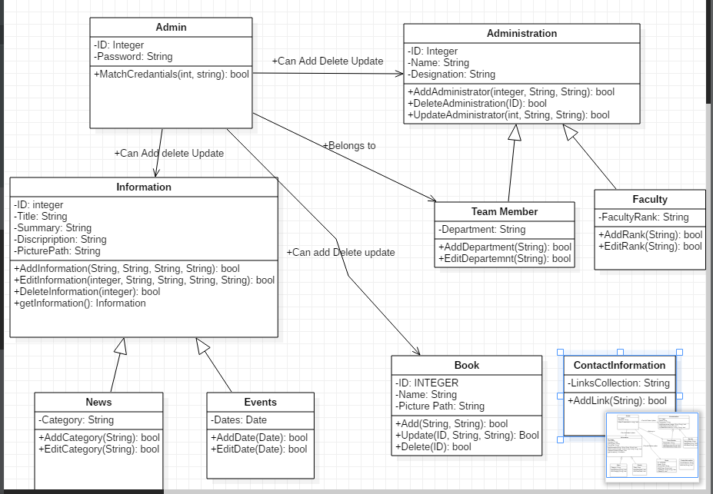

**ER Diagram**

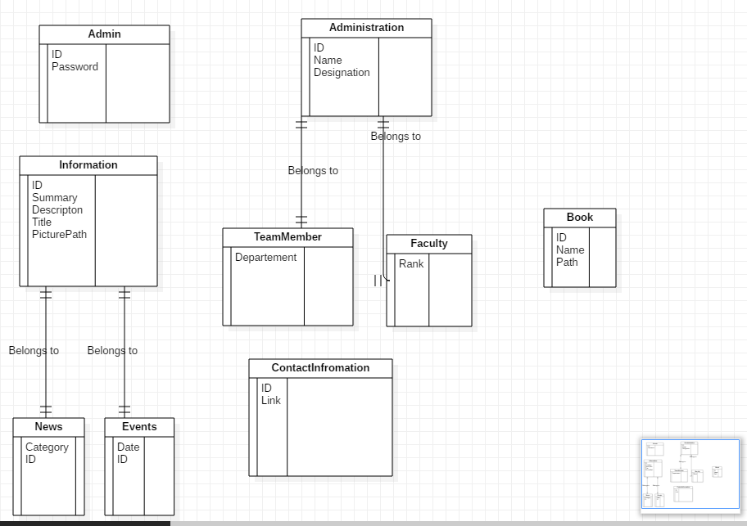

**Data flow Diagram**  
  
  
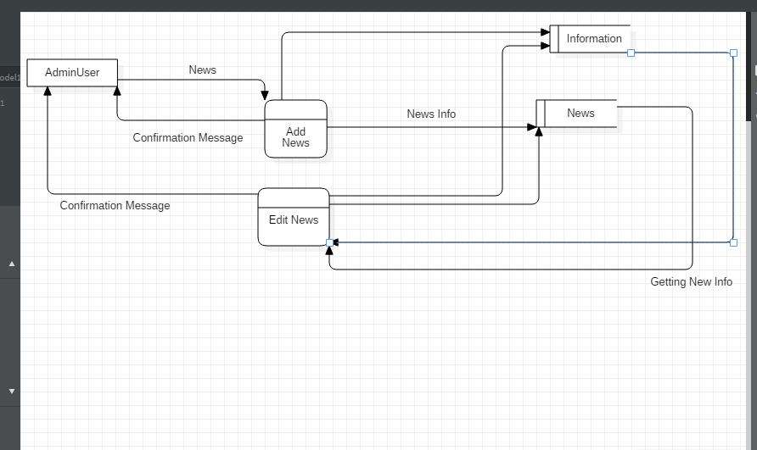  
  
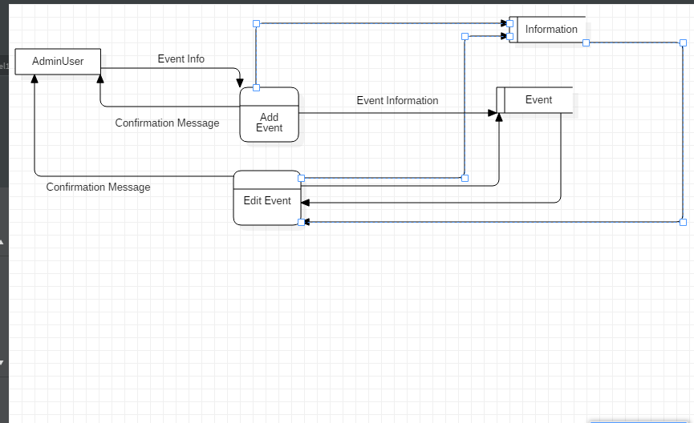  
  
  
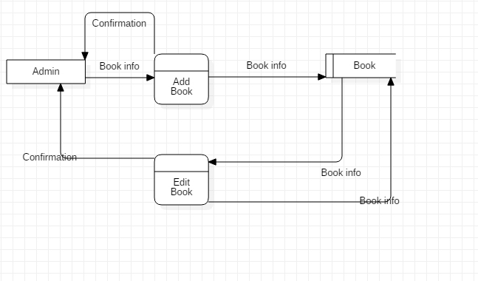  
  
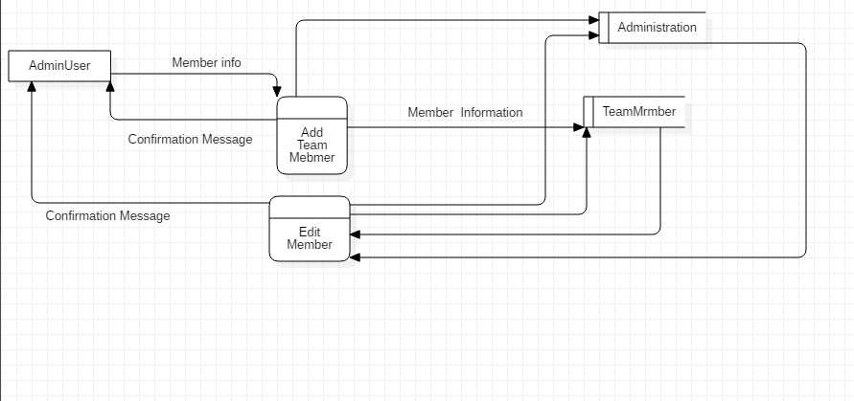  
  
  
  
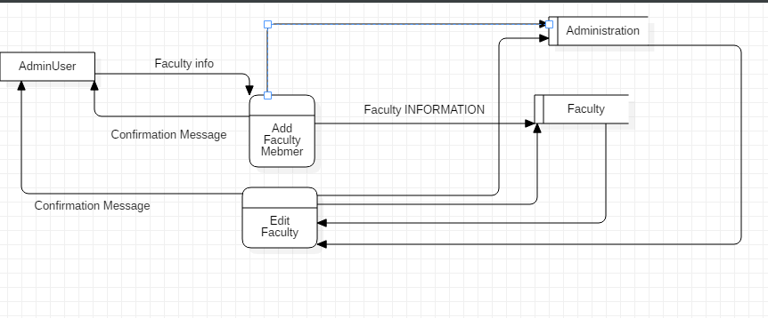

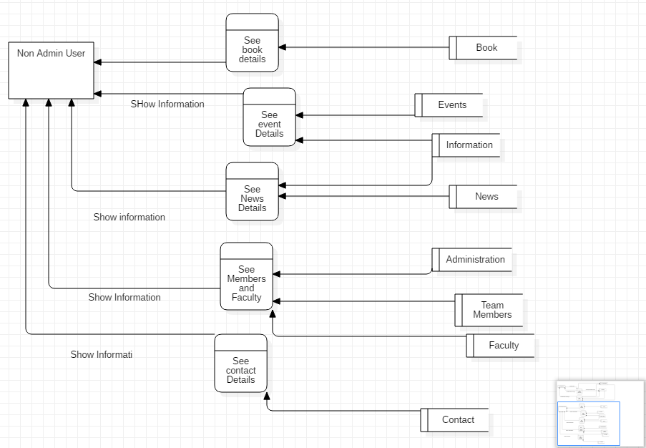

**Use Case Diagram** 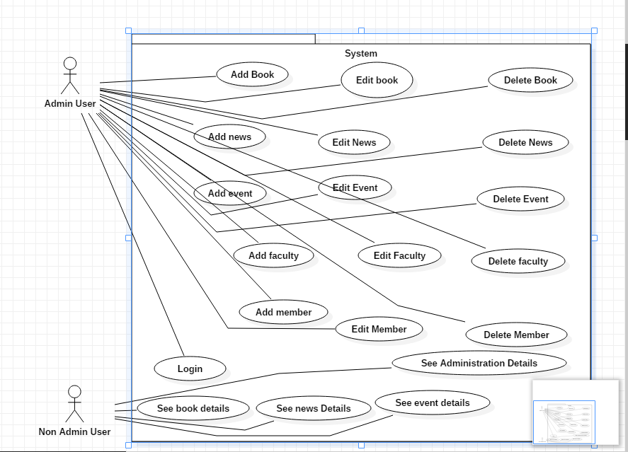

# Appendix C: Design Models

Component diagrams  
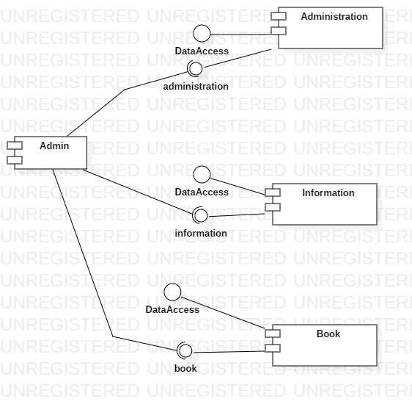

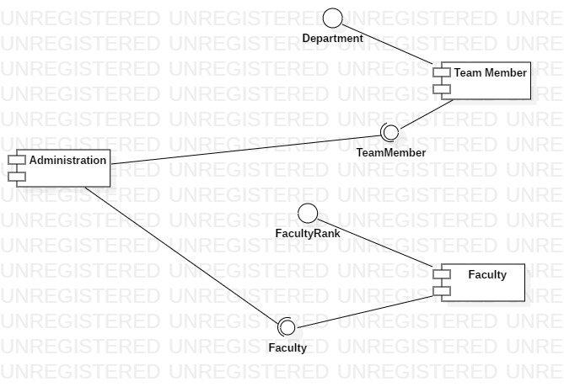

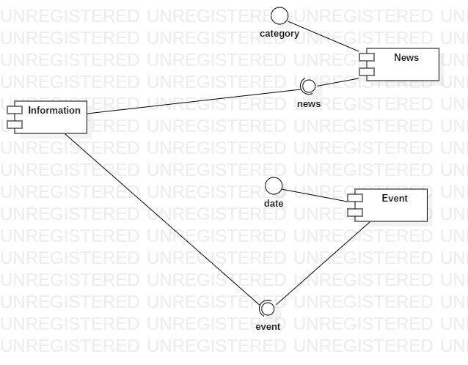

Appendix D: Screenshots

< Include all screenshots of your software application’s graphical user interface.>

Appendix E: Test Cases

· < Fill out the following template for each test case.>

·

|  |  |
| --- | --- |
| Identifier | TC-1 |
| Priority | <Choose one from {High, Medium, Low}> |
| Related requirements(s) | <Include use-case identifier(s) for functional requirement(s) and SRS section/sub-section number(s) for other requirement(s).> |
| Short description | … |
| Pre-condition(s) | … |
| Input data | … |
| Detailed steps | … |
| Expected result(s) | … |
| Post-condition(s) | … |

Table 2: TC-1

Appendix F: IV & V Report

IV & V Resource

Name Roll # Signature

·

|  |  |  |  |  |  |
| --- | --- | --- | --- | --- | --- |
| S# | Defect Description | Origin Stage | Status | Fix Time | |
| Hours | Minutes |
| 1 |  |  |  |  |  |
| 2 |  |  |  |  |  |
| 3 |  |  |  |  |  |
| … |  |  |  |  |  |

Table 3: List of non-trivial defects

Appendix G: Risk Report

[1]Project Risks

|  |  |  |  |  |  |
| --- | --- | --- | --- | --- | --- |
| Risk Description | Impact  (1 – 10) | Probability  (0 – 1) | [2]Risk  Exposure | Weeks Active | Mitigation Strategy |
|  |  |  |  |  |  |
|  |  |  |  |  |  |
|  |  |  |  |  |  |
|  |  |  |  |  |  |
|  |  |  |  |  |  |

·

Appendix H: Activity Timesheet

|  |  |  |
| --- | --- | --- |
| Activity | Time | |
| Hours | Minutes |
| Requirements Engineering |  |  |
| Analysis and Design |  |  |
| Implementation |  |  |
| Testing |  |  |
| Deployment |  |  |
| Project Management |  |  |
| IV & V |  |  |

Project Manager

Name Roll # Signature

·

Appendix I: Updated Project Plan

· < Include screenshots of your updated project plan prepared using MS Project.>

·

[1] Risks should be sorted in descending order of risk exposure.

[2] Risk Exposure = Risk Impact x Risk Probability